LEAN SOFTWARE DEVELOPMENT:

* Lean Software Development (LSD) is an agile framework based on optimizing development time and resources, eliminating waste, and ultimately delivering only what the product needs.

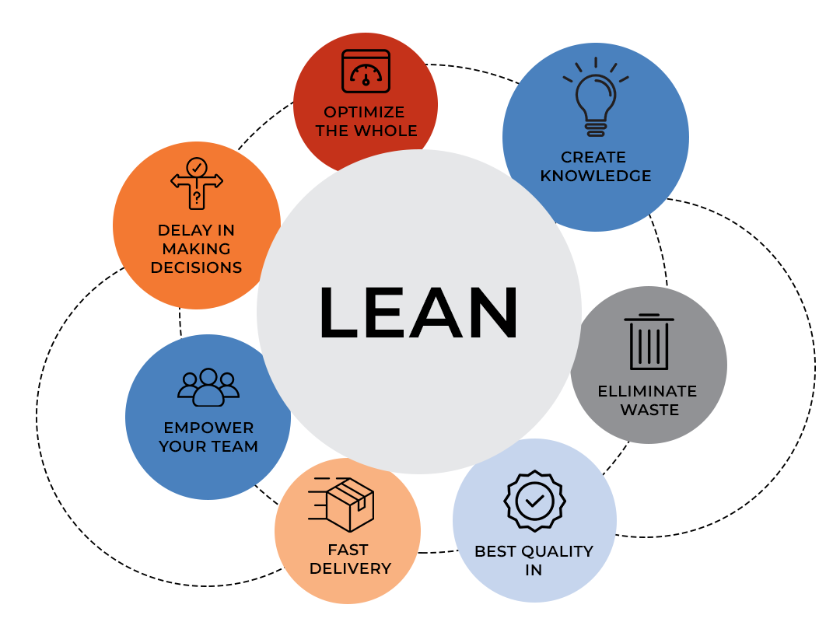

**Eliminate waste:**

To maximize value, we must minimize waste.

1. partially done work =>work is started, but not completed
2. waiting=>delays waiting for reviews and approvals

**Empower the team:**

By empowering your teams to self-organize to co-create an empowered, innovative, customer-centric culture

**Deliver fast:**

The agile process allows software features to be delivered much faster (ideally, every four weeks or less), significantly speeding up the functionality delivered. Delivering fast is another key principle of lean software development. It allows a team to test assumptions early on.

**Optimize the whole:**

caring about the flow of value through the entire process from beginning to end

**Build quality In:**

Analysis, deploying, design and supporting customer are come under build quality In. Built-In Quality is a Lean management practice that aims to proactively address quality issues before they turn into large-scale problems by applying continuous improvement tools to the production process.

**Defer decisions**

the team and the client's opinion is getting contradicted and time permits to delay this deferred decision situation, then LSD suggests taking this opportunity and delay the decision as it may be resolved on its own.

**Amplify Learning:**

Through extensive code review and cross-team meetings, the learning is enhanced. “Amplify learning” is a Lean development principle centered around creating knowledge in the process, which is essential for maximizing value delivery to customers.